|  |  |  |  |  |  |  |  |
| --- | --- | --- | --- | --- | --- | --- | --- |
| Submission Coversheet | | | |  |  |  |  |
|  |  |  |  |  |  |  |  |
| **Student ID Number** | S00041694 | | | | | | |
| **Programme Title** | Computing Technologies Degree | | | | | | |
| **Module Title** | Web Development | | | | | | |
| **Module Code** (listed on Moodle and in LTAFP) | [QAC020C153A](https://partnerships.moodle.roehampton.ac.uk/course/view.php?id=489) | | | | | | |
| **Module Convenor** | Ekereuke Udoh | | | | | | |
| **Coursework Title** | Coursework1: JS Wedding Planners | | | | | | |
| **Academic Declaration:**  Students are reminded that the electronic copy of their essay may be checked, at any point during their degree, with Turnitin or other plagiarism detection software for plagiarised material. | | | | | | | |
| **Word Count** | 7458 | | | **Date Submitted** | | **10/12/2018** | |
|  |  | | |  | |  | |

Table of Contents

Introductory information 3

Web Site Design 3

Introduction 3

Site Map Schematic 3

Webpage Wireframes 4

Home Page Desktop Wireframe 5

Home Page Tablet Wireframe 6

Home Page Mobile Wireframe 7

Portfolio Page Desktop Wireframe 9

Portfolio Page Tablet Wireframe 11

Portfolio Page Mobile Wireframe 12

Packages Page Desktop Wireframe 15

Packages Page Tablet Wireframe 16

Packages Page Mobile Wireframe 17

Services Page Desktop Wireframe 19

Services Page Tablet Wireframe 21

Services Page Mobile Wireframe 21

Contact Page Desktop Wireframe 21

Contact Page Tablet Wireframe 21

Contact Page Mobile Wireframe 21

Development: 21

Introduction 21

Project Files 21

Testing and validation: 21

References 21

# Introductory information

Js Wedding Planners is a web project defined and designed by and for dTech Limited, a very well-known UK top company, in the communications industry. The web site was created to extend their business and for reaching out new online customers, but also to provide a way of contact for their existing clients.

The project is meant to provide useful information about the company’s services like: photography, cakes, venue booking, wedding planning, transport and florist but also to bring out their portfolio, their standard packages and a way to contact them.

# Web Site Design

## Introduction

The web project is consisted of five pages: home, portfolio, packages, services and contact. Each page has its own unique responsive design and a common template for the header, content and footer.

## Site Map Schematic

As presented in Figure 1 the site map shows the list of the web pages and the hierarchical relations between them.

Every page can access any other page, including themselves, with the main menu represented by the black arrow lines and can also go to their neighboring pages, represented in the figure below by the red arrow lines, with the help of the left and right buttons in the header area.

Having multiple options for the browsing of the site ensures that it is going to have a good impact on the client’s user experience by giving him choices on any type of device thus adding mobility on phones and tablets.

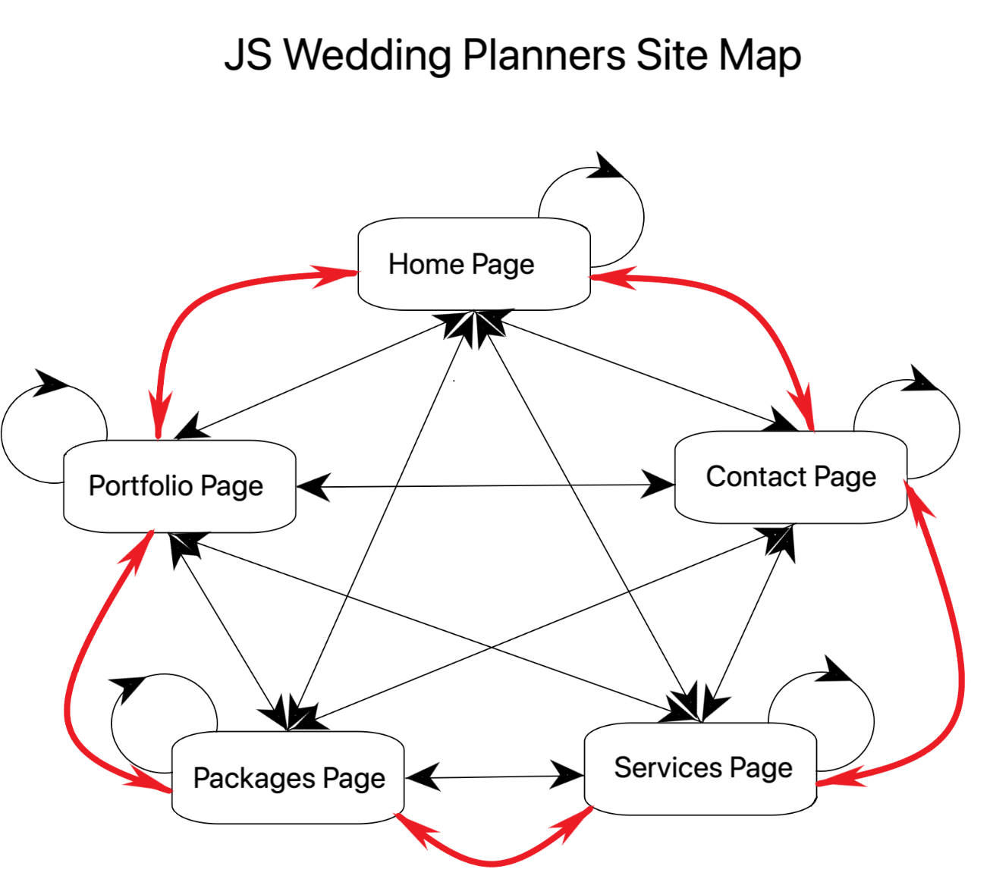

Figure 1

## Webpage Wireframes

The JS Wedding Planners web page wireframes represent a rough approximation sketch to help the client and the developer have a better image and understanding of the hole schematic of the project.

Each page is divided into three sub-wireframes categories represented by the type of the device it is portraying: desktop, tablet or mobile. Not all wireframes will have adnotated text because it will be redundant to do so. Only newly introduced objects will be explained in the sketches below.

### Home Page Desktop Wireframe

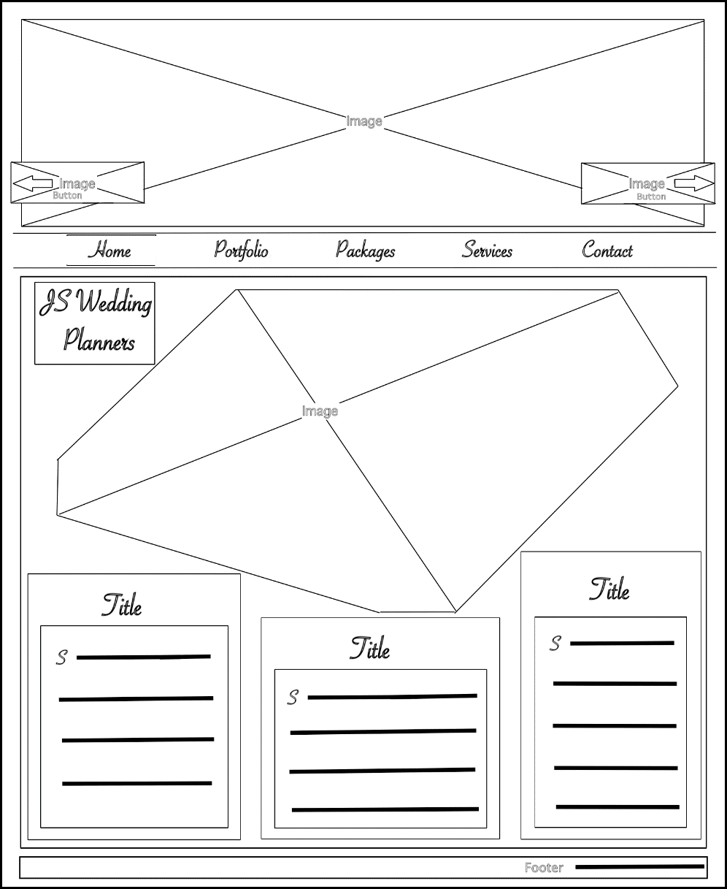

Secondary Image

Link Image represented as a button for accessing the Contact Page

Link Image represented as a button for accessing the Portfolio Page

Brand name text/ intersects with secondary image

Text box with title and paragraph/ intersects with secondary image/uses local font for the title and the first character of the paragraph

Text box with title and paragraph/ does not intersect with secondary image/uses local font for the title and the first character of the paragraph

Text box with title and paragraph/ intersects with secondary image/uses local font for the title the first character of the paragraph

Footer section containing information like copyright and name

Menu selection, highlighted with a thin top and bottom border

Main menu highlighted with a thin top and bottom border/ on hovering over the list’s elements the menu item is highlighted with a contrasting background color

Content section differentiating from the body with a lighter background color

The body container highlighted with a darker background color

Main Page Image

Figure 2

### Home Page Tablet Wireframe

The home page is compatible with the tablet resolutions, resizing its elements accordingly. No major changes occur in comparison with the desktop variant, apart from having bigger, left and right, buttons

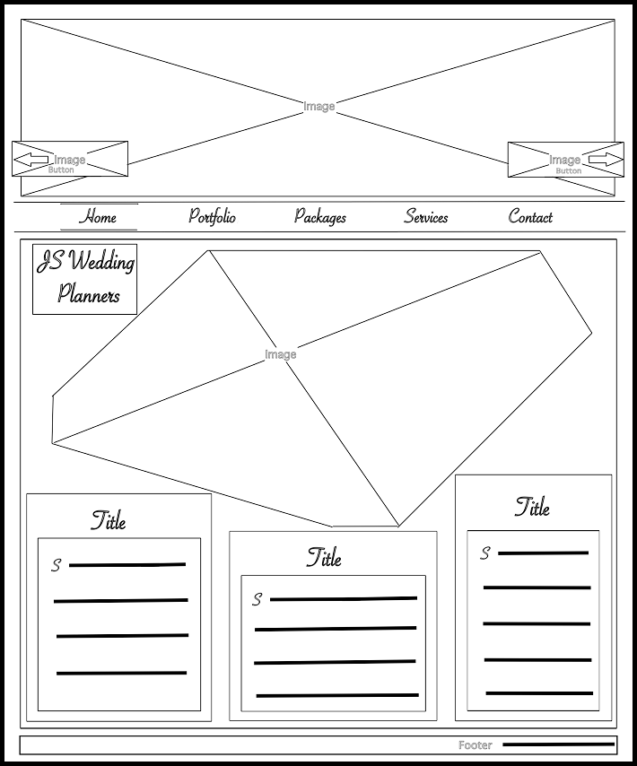

Figure 3

### Home Page Mobile Wireframe

* Hidden home menu state:

Figure 4

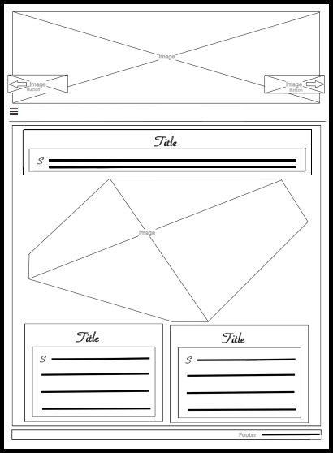

Main menu is hidden on mobile devices/can be viewed in vertical mode when the toggle button is pressed

Toggle button contained by the main menu with the task to show and hide the listed items on mobile devices/ it also highlights the position of the current page by contrasting it’s referenced line out of the five ones into a lighter and brighter color nuance.

Because of the low resolution on mobile devices the middle text box has been moved at the top of the content section.

Because of the low resolution on mobile devices the left text box occupies half of it’s previous desktop container.

Because of the low resolution on mobile devices the right text box occupies half of it’s previous desktop container.

* Visible home menu state:

Figure 5

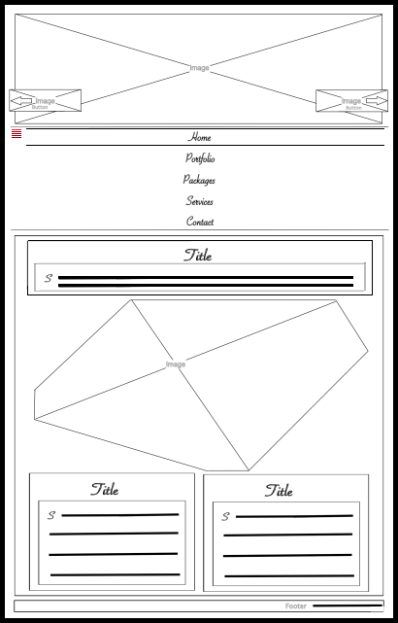

The main menu is shown in vertical mode on mobile devices, after the toggle is pressed/The toggle button mantains its position after it is pressed and the list items are vertically aligned and flow to the right.

Selected menu item highlighted as in the desktop view with a thin top and bottom border.

### Portfolio Page Desktop Wireframe

Figure 6

The content section houses the portfolio gallery/ The gallery is divided into 4 equal collumns

The red paranthesis highlights that the selected subsection is a column consisted of images

Image with no border

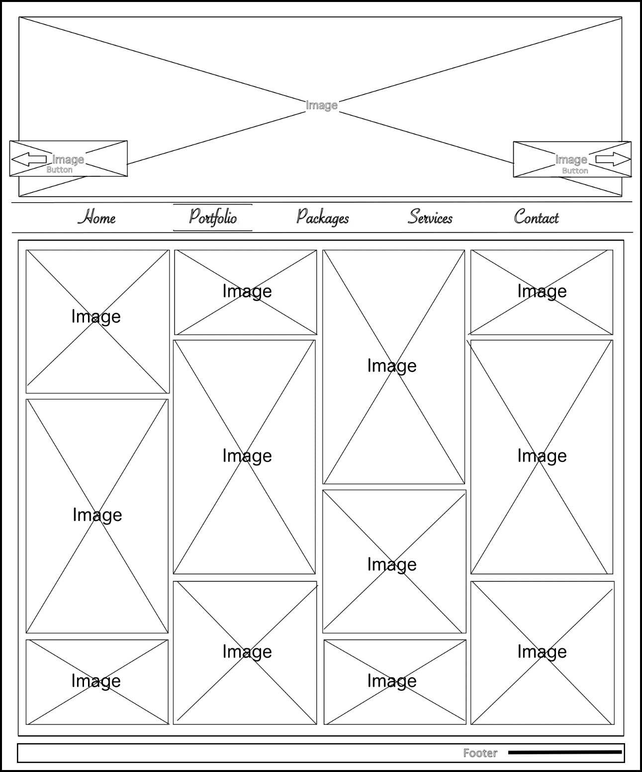

### Portfolio Page Tablet Wireframe

Figure 7

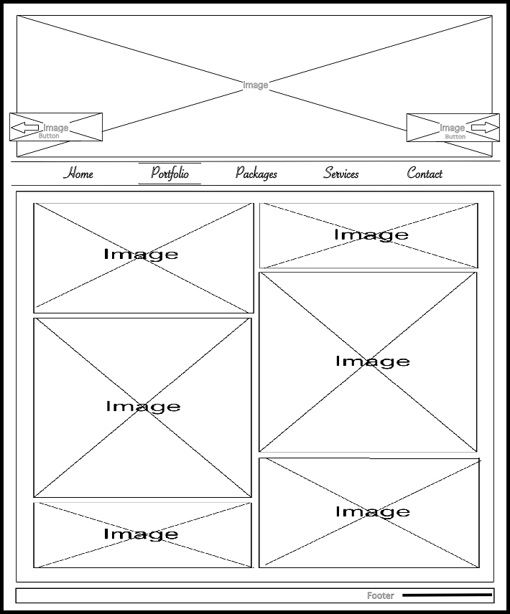

Because of the smaller resolutions on the tablet devices, the gallery resizes to a two columns gallery view

### Portfolio Page Mobile Wireframe

* Hidden portfolio menu state:

Figure 8

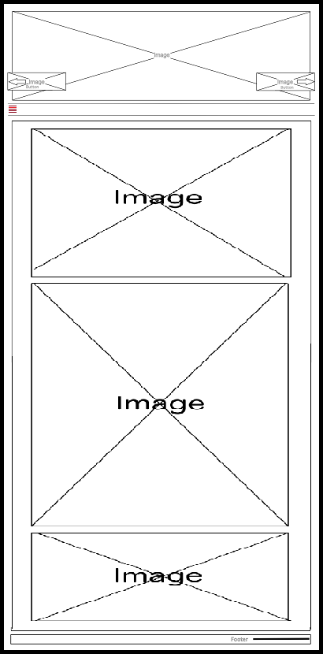

On the mobile devices the content resizes to a one column gallery

* 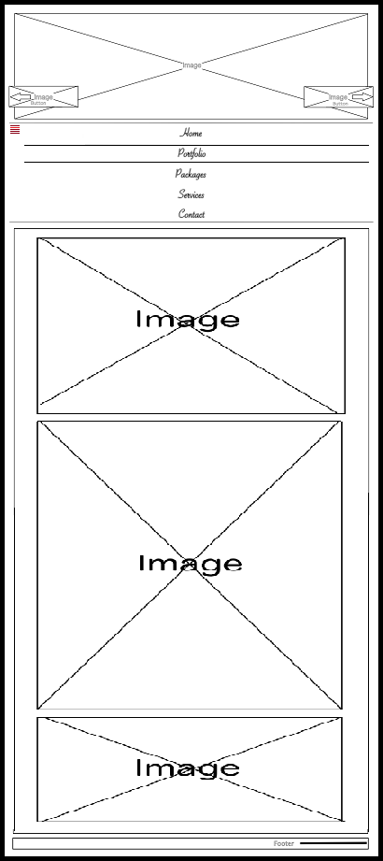Visible portfolio menu state:
* Visible portfolio menu state:



### Packages Page Desktop Wireframe

Figure 9

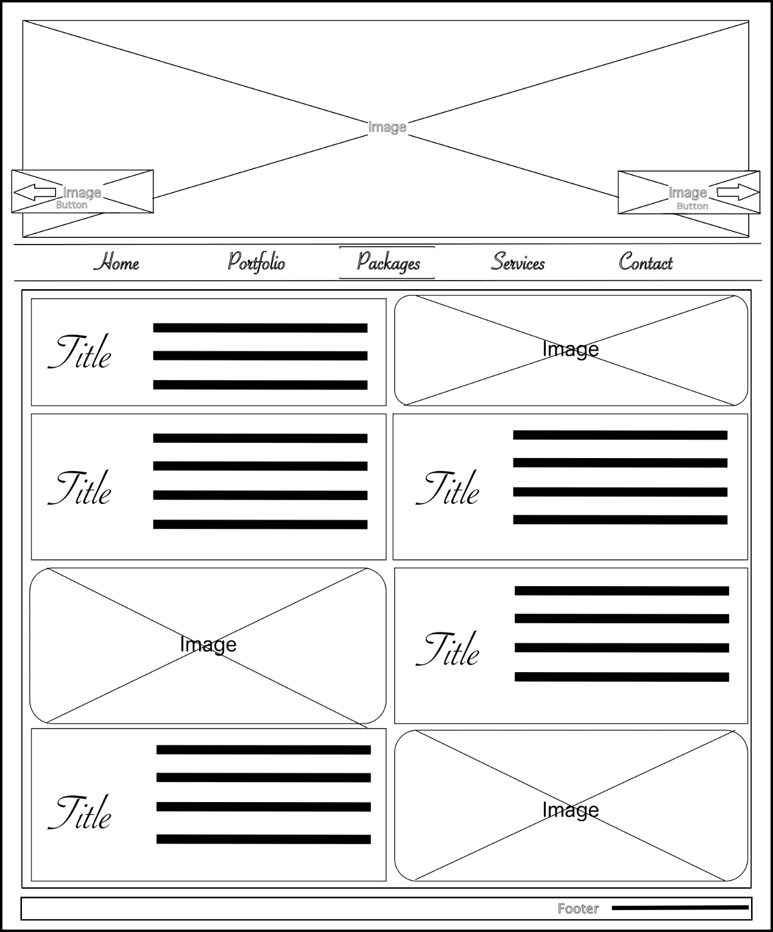

The content section houses the packages offers and some images/ The gallery is divided into 2 equal columns consisting of articles and images

Image with no border and rounded at the corners

Box text with the title floating left and the paragraph right

### Packages Page Tablet Wireframe

Figure 10

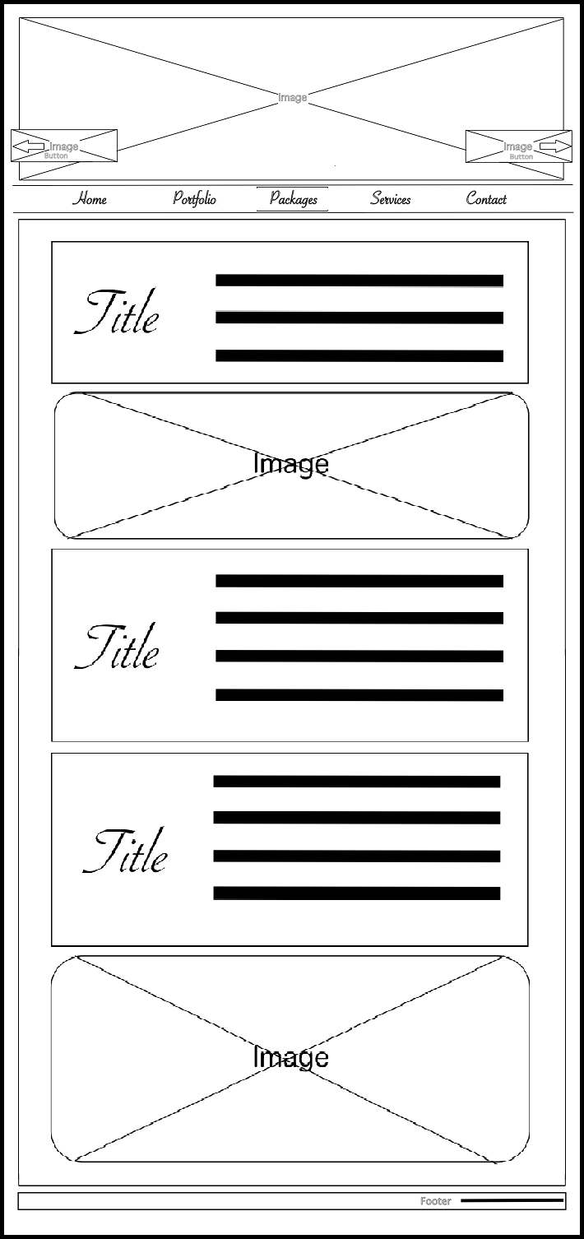

On tablet resolutions the content resizes to one column view and the items are listed in the order their inserted in the html file

### Packages Page Mobile Wireframe

* Hidden packages menu state:

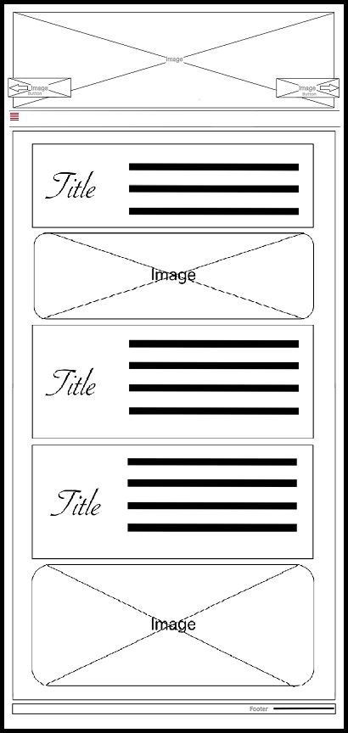

Figure 11

* Visible packages menu state:

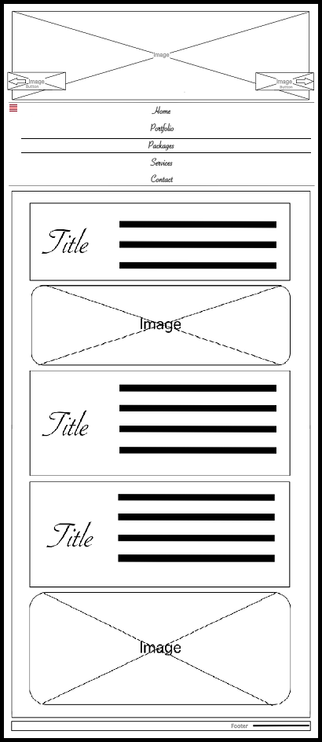

Figure 12

### Services Page Desktop Wireframe

Figure 13

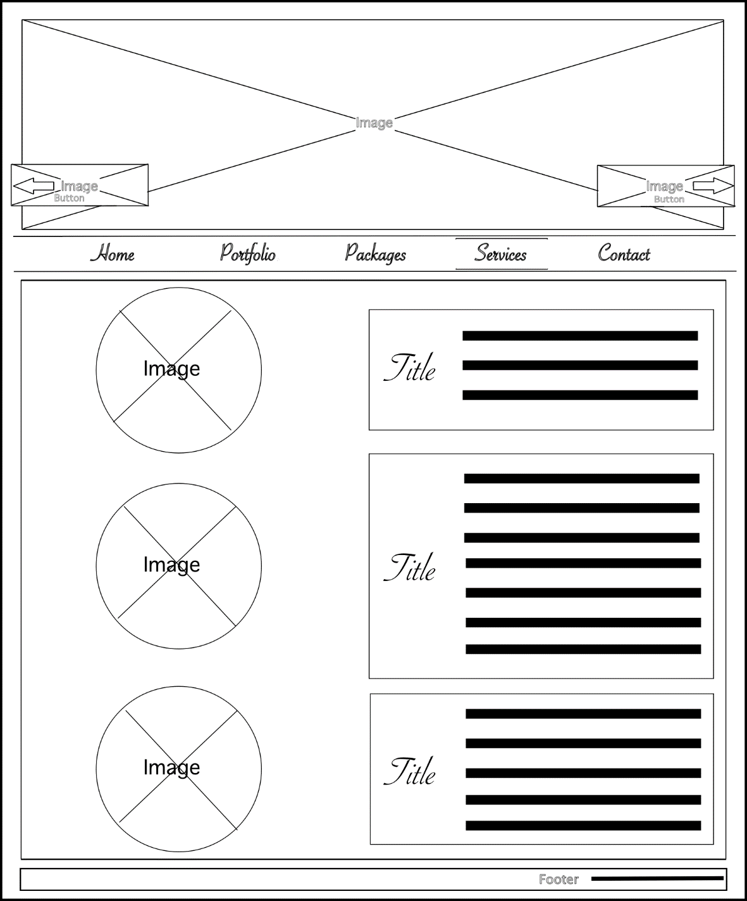

The content is represented by a grid with two columns which contains images on the left and articles on the right

Rounded image with no border

### Services Page Tablet Wireframe

Figure 14

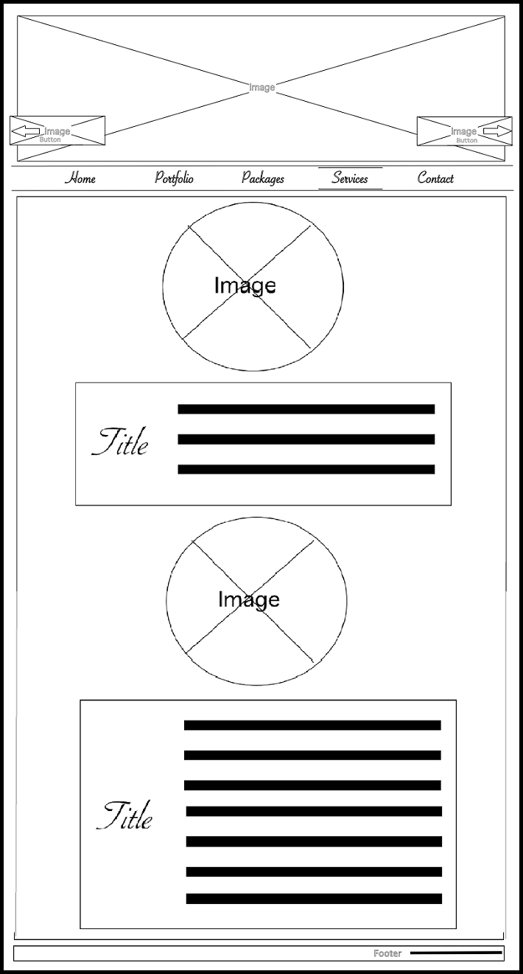

On tablet resolution the content resizes into a grid with one column in which every image is followed by its article

### Services Page Mobile Wireframe

* Hidden services menu state:

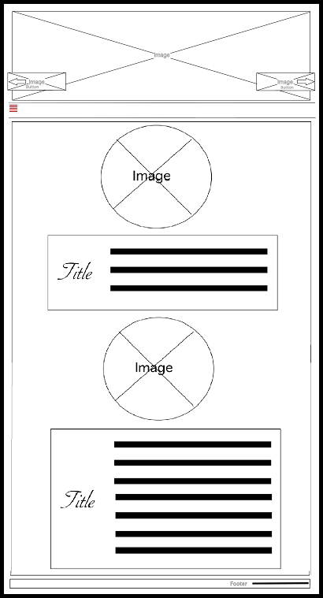

Figure 15

* Visible services menu state:

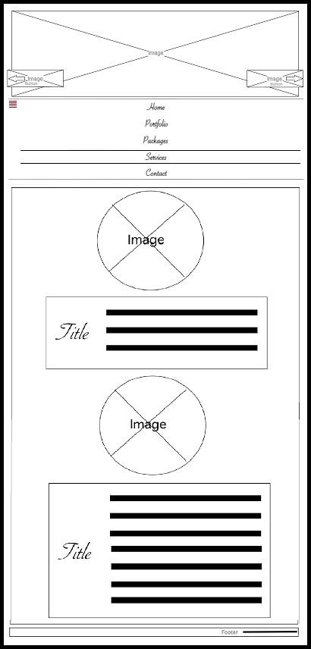

Figure 16

### Contact Page Desktop Wireframe

Figure 17

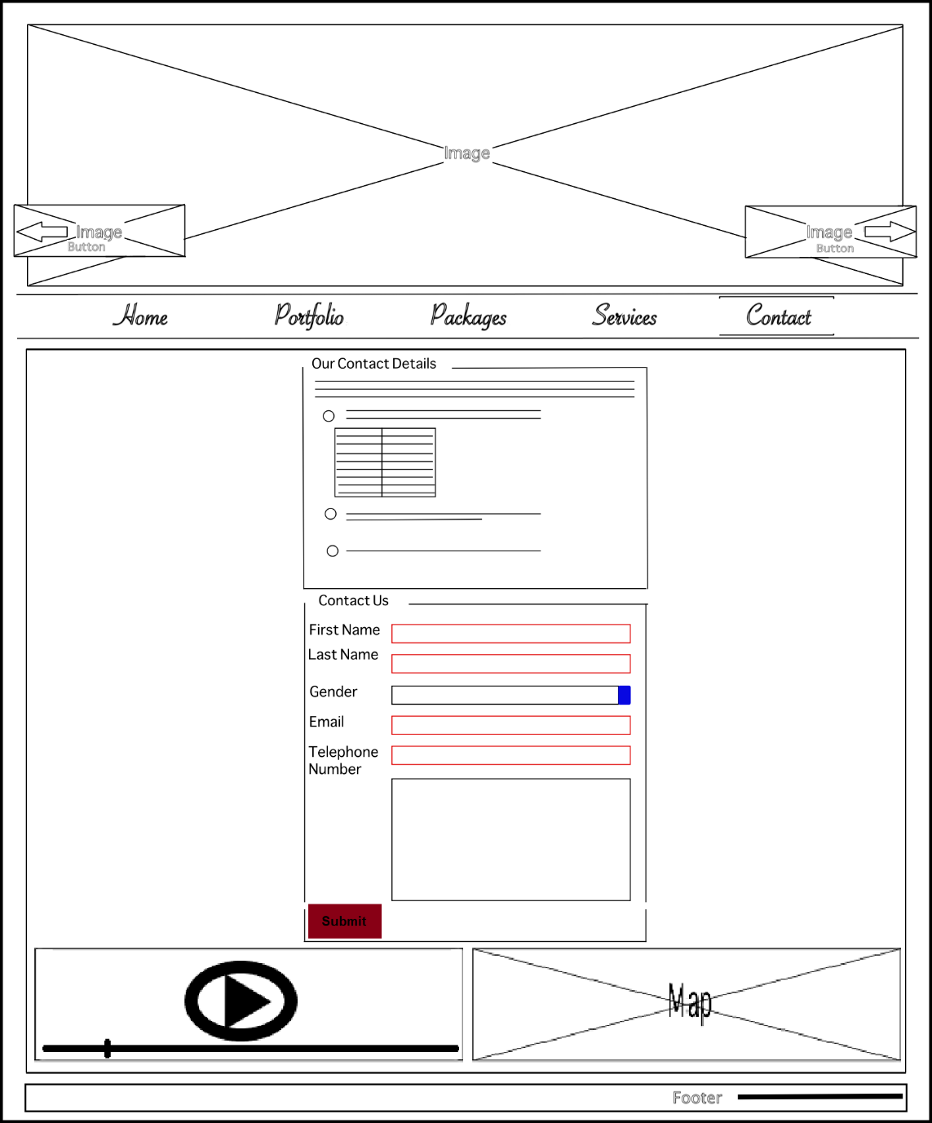

The content houses two centered field-sets and a grid with two columns containing a video and a Bing map

The top field-set represents the contact details of the company.

Introducing paragraph

Unordered list enumerating the multiple contact options

Table containing working hours

Input field for requesting the user’s first name, last name, email and telephone number. The inputs have autofocus and are required with a custom pattern set for each one

Select box containing gender options with default value

Text area with the properties that it is required and has autofocus

Bing map containing the location of the company/ it is set in the left part of a grid with minimal control

Video containing info on how to reach the location of the company/ It used as a second option in case the map service doesn’t work/ It is set with controls and error message

Labels paired with their input

Form data for submitting info about the client/ The display property is set as table

Button used to submit data through a post request

### Contact Page Tablet Wireframe

Figure 18

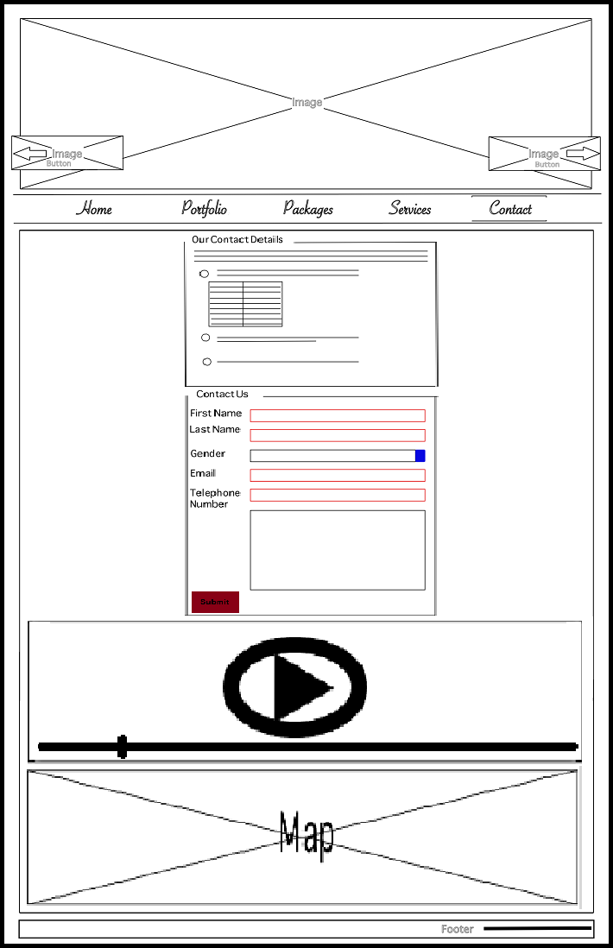

On the tablet resolutions the grid converts to one column putting the video on the first row and the map on the second row

### Contact Page Mobile Wireframe

* Hidden contact menu state:

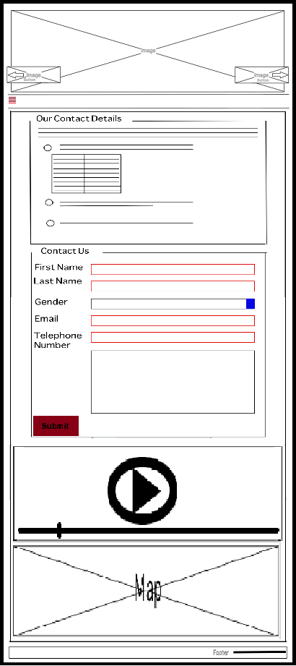

Figure 19

* Visible contact menu state:

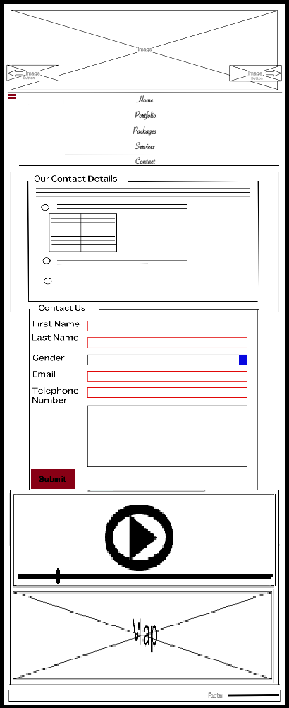

Figure 20

# Development:

## Introduction

## Project Files

# Testing and validation:

# References